LO-SF-1G-ZX
1.25Gbps SFP 1550nm Optical Transceiver 80KM LC DDM

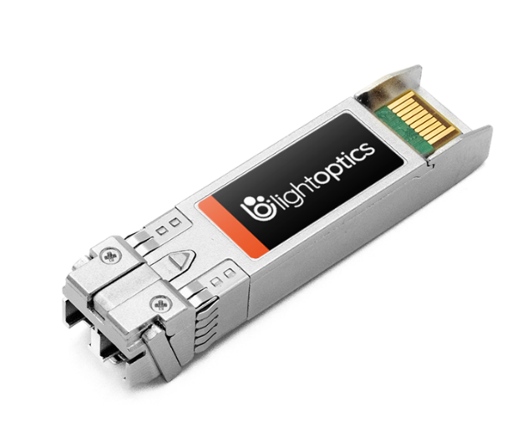
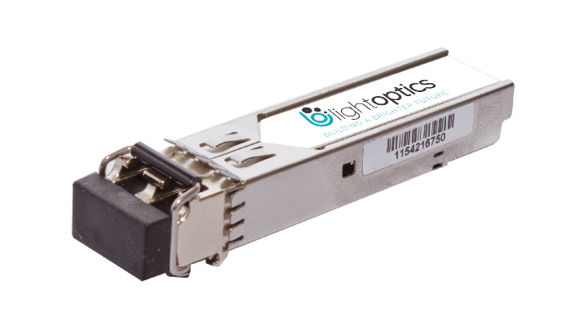
Product Features
- SFP package with LC connector
- 1550nm DFP laser and APD photo detector
- Up to 120Km transmission on SMF
- +3.3V single power supply
- LVPECL compatible data input/output interface
- Low EMI and excellent ESD protection
- Laser safety standard IEC-60825 compliant
- Compatible with RoHS

Applications
- 1.25Gb/s 1000Base-ZX Ethernet

Ordering information
Part Number | Product Description
LO-SF-1G-ZX | SFP 1.25Gbps ZX+ 1550nm LC DDM SMF 80km

Parameter | Symbol | Minimum | Maximum | Units
Storage Temperature | Tst | -40 | 85 | ºC
Supply Voltage | Vcc | 0 | 3.6 | V
Operating Relative Humidity | RH | 5 | 95 | %
Absolute Maximum Ratings

Recommended Operating Conditions
Parameter | Symbol | Minimum | Typical | Maximum | Unit
Operating Case Temperature | T_{C} | 0 |  | 70 | ºC
Supply Voltage | V_{CC} | 3.15 | 3.3 | 3.45 | V
Data Rate | - | - | 1.25 | - | Gb/s

Transceiver Electrical Characteristics
Transmitter  Parameter |  | Symbol |  | Minimum |  | Typical |  | Maximum |  | Unit |  | Notes
Input Differential Impedance |  |  | Z_{IN} |  | 90 |  | 100 |  | 110 |  | Ω |  | -
Differential Data Input Swing |  |  | V_{IN} |  | 500 |  | - |  | 2400 |  | mV |  | -
TX_FAULT | Transmitter Fault |  | V_{OH} |  | 2.0 |  | - |  | V_{CC} |  | V |  | -
TX_FAULT | Normal Operation |  | V_{OL} |  | 0 |  | - |  | 0.8 |  | V |  | -
TX_DISABLE | Transmitter Disable |  | V_{IH} |  | 2.0 |  | - |  | V_{CC} |  | V |  | -
TX_DISABLE | Transmitter Enable |  | V_{IL} |  | 0 |  | - |  | 0.8 |  | V |  | -
Receiver  Parameter |  | Symbol |  | Minimum |  | Typical |  | Maximum |  | Unit |  | Notes
Output Differential Impedance |  |  | Z_{O} |  | - |  | 100 |  | - |  | Ω |  | -
Differential Data Output Swing |  |  | V_{OUT} |  | 370 |  | - |  | 2000 |  | mV |  | -
RX_LOS | Loss of signal (LOS) |  | V_{OH} |  | 2.0 |  | - |  | V_{CC} |  | V |  | -
RX_LOS | Normal Operation |  | V_{OL} |  | 0 |  | - |  | 0.8 |  | V |  | -

Transmitter Optical Characteristics
Parameter | Symbol | Minimum | Typical | Maximum | Unit | Notes
Center Wavelength Range | λc | 1540 | 1550 | 1560 | nm | -
Spectral Width (RMS) | Δλ | - | - | 1 | nm | -
Extinction Ratio | ER | 8 | - | - | dB | -
Average Output Power | Po | 5 | - | -2 | dBm | -
Rise/Fall Time(20%~80%) | Tr/Tf | - | - | 180 | ns | -
Total jitter | Tj | - | - | 0.43 | Ul | -
Optical Eye Diagram | IEEE 802.3z and ANSI Fibre Channel Compatible

Receiver Optical Characteristics
Parameter | Symbol | Minimum | Typical | Maximum | Unit | Notes
Center Wavelength | λc | 1260 | - | 1620 | nm | -
Receiver Sensitivity | Rsen | - | - | -24 | dBm | -
Receiver Overload | Rov | -3 | - | - | dBm | -
Optical Return Loss | ORL | 12 | - | - | dB | -
LOS De-Assert | LOS_{D} | - | - | -25 | dBm | -
LOS Assert | LOS_{A} | -36 | - | - | dBm | -
LOS Hysteresis | - | 0.5 | - | 5 | - | -

Mechanical specifications
